SCREENSHOTS OF THE PROJECTS
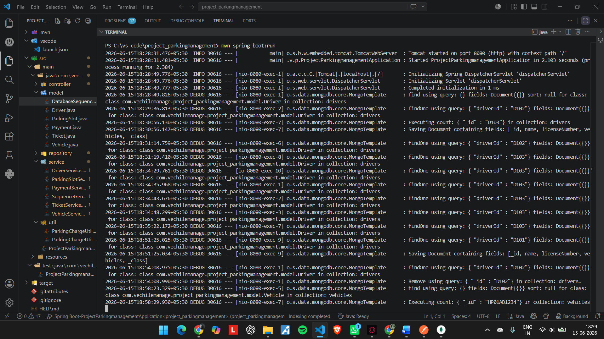
Terminal showing – changes appeared on the Terminal
--------------------------------------------------------------------------------------------------------------------------
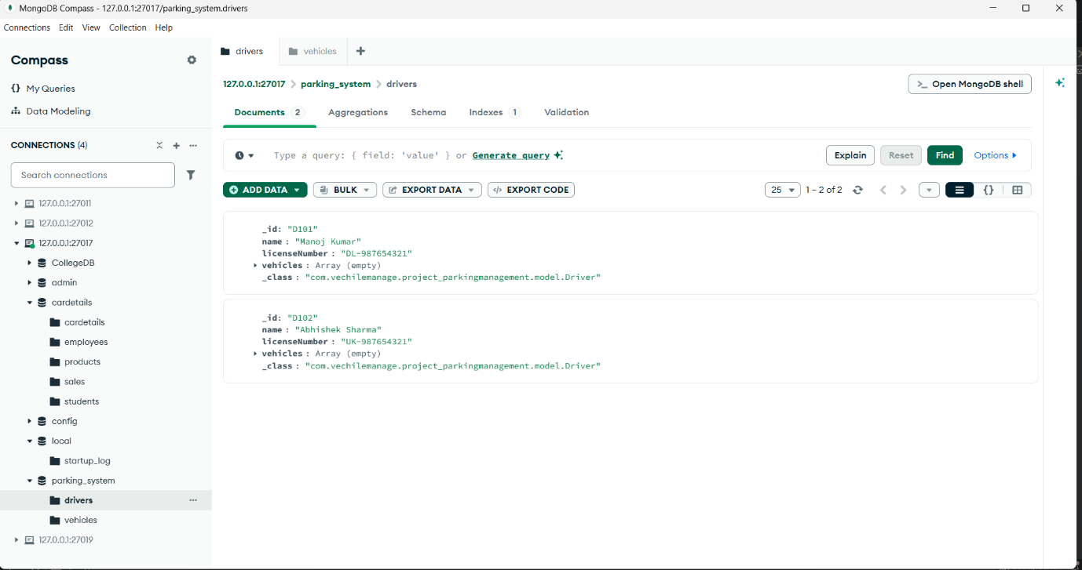
MongoDB_Database_for_Driver( MongoDB Compass)
--------------------------------------------------------------------------------------------------------------------------

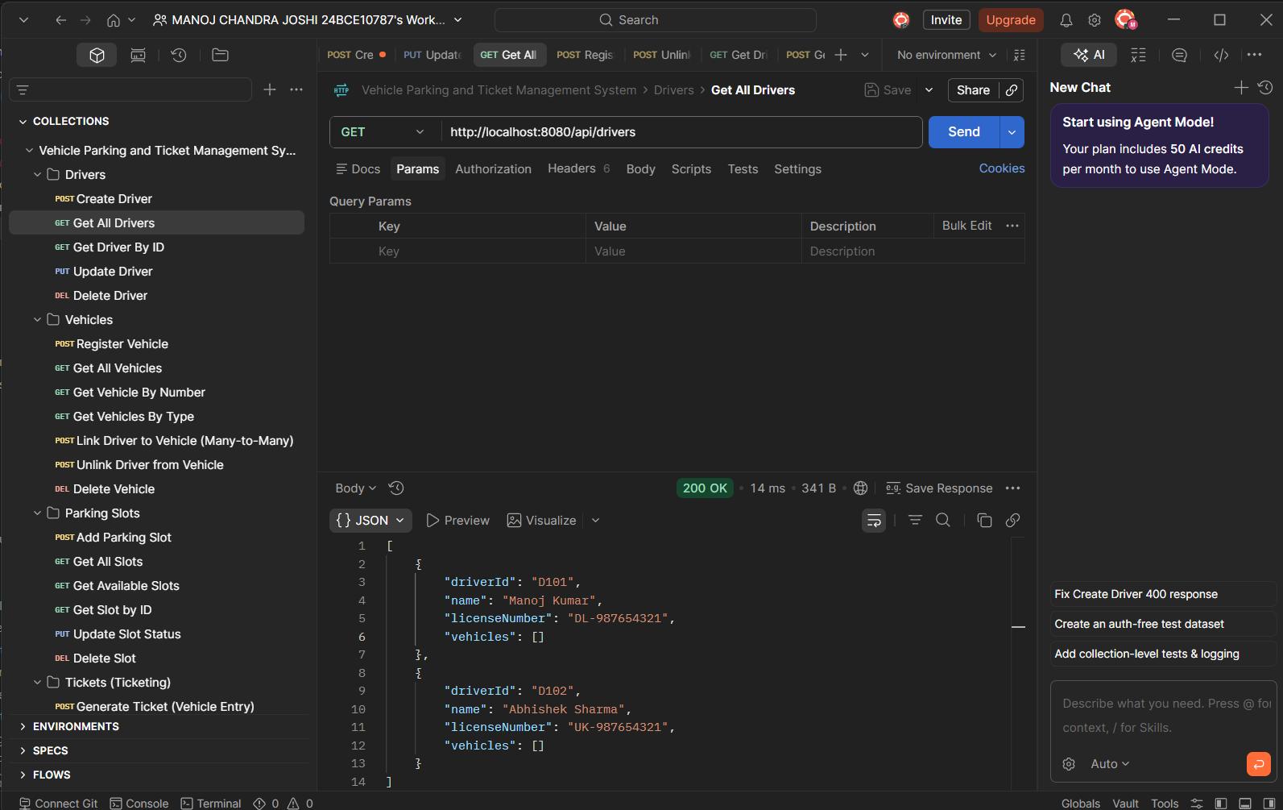
Postman screenshot for DRIVER Method - GET
------------------------------------------------------------------------------------------------------------------------
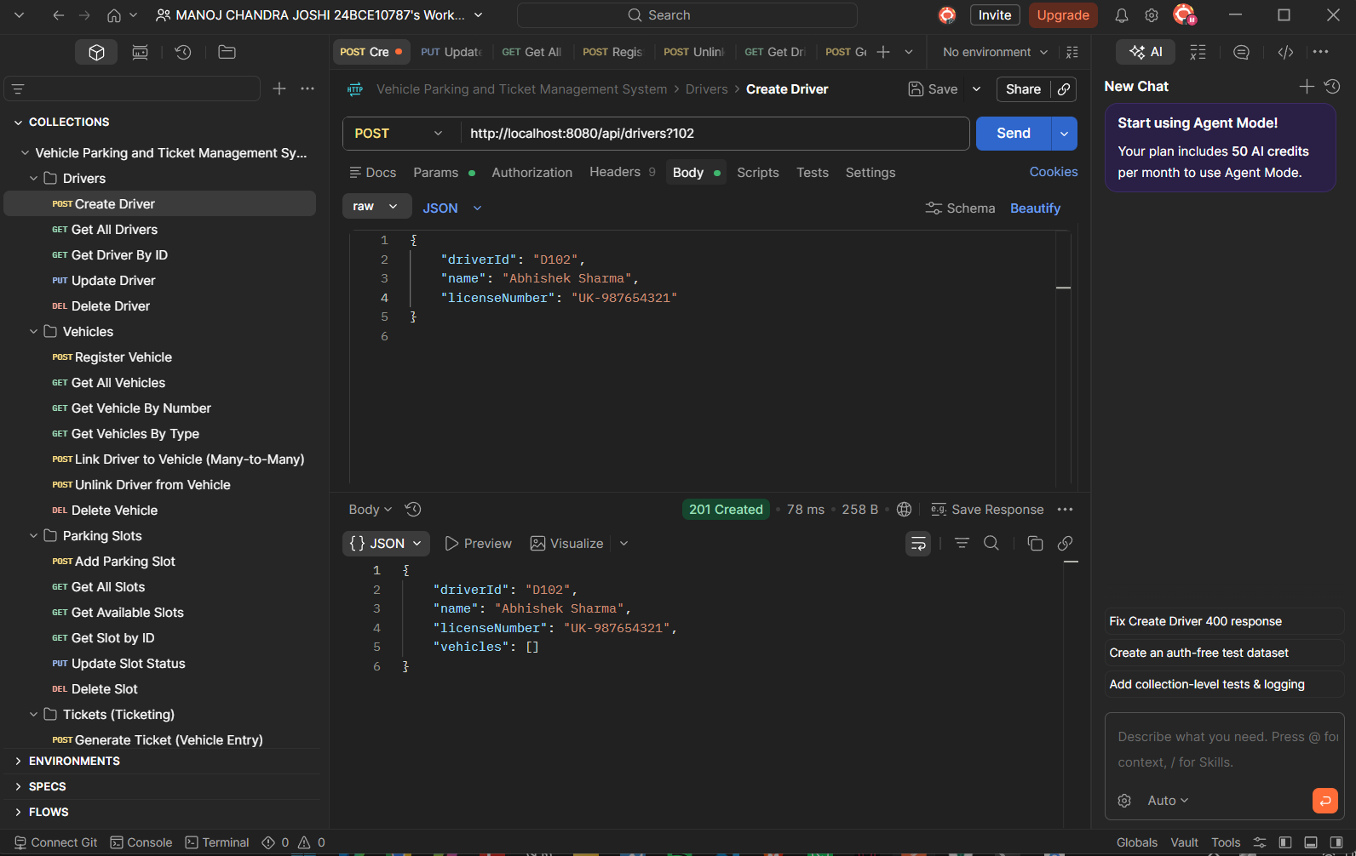
Postman screenshot for DRIVER Method POST
--------------------------------------------------------------------------------------------------------------------------

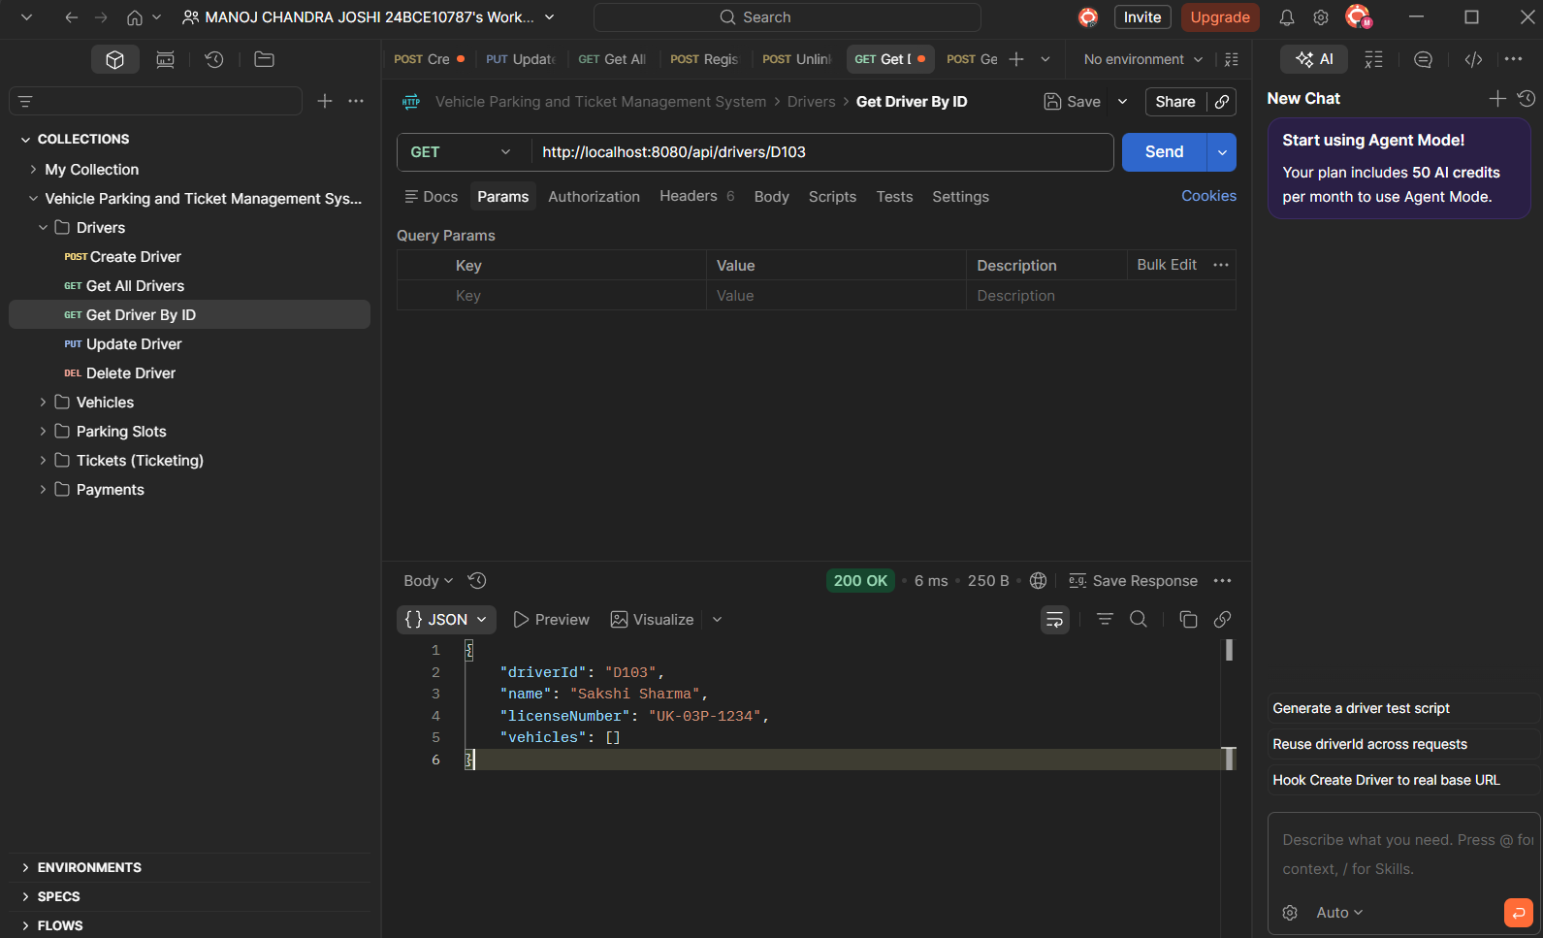
GET Driver by id FIND OPERATION

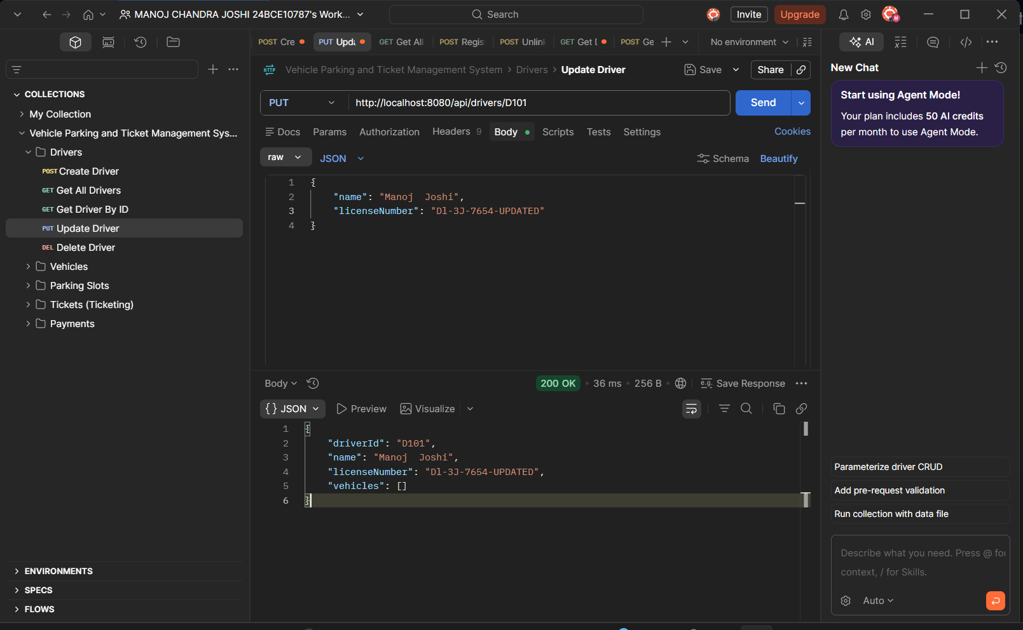
PUT Method used to edit Driver name and licenseNumber for D101
--------------------------------------------------------------------------------------------------------------------------
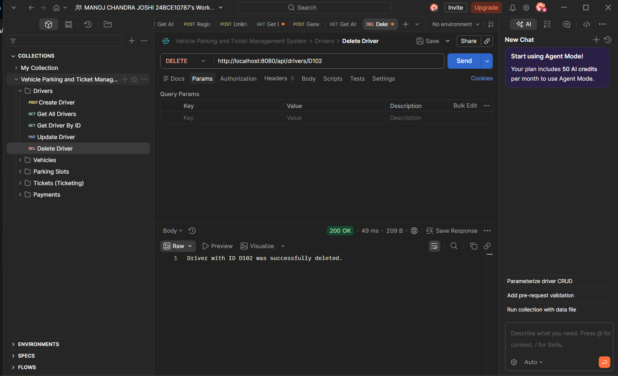
DELETE Method used to delete D102
--------------------------------------------------------------------------------------------------------------------------
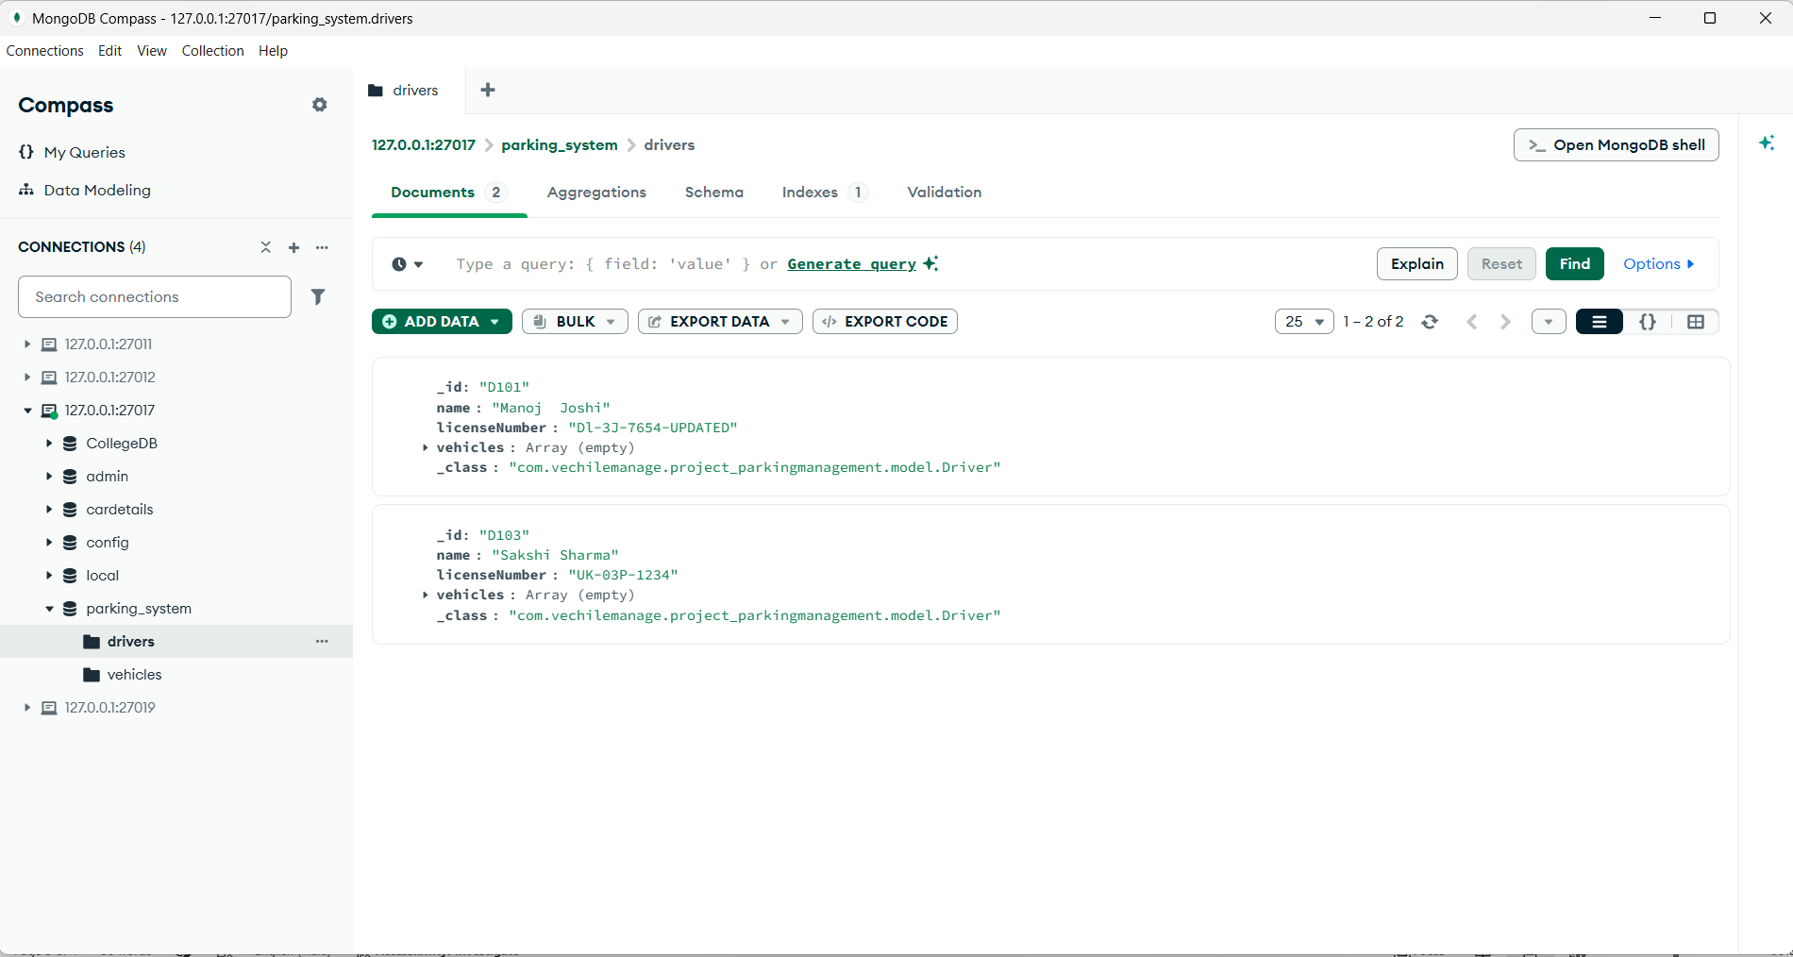
Updated MongoDB Database

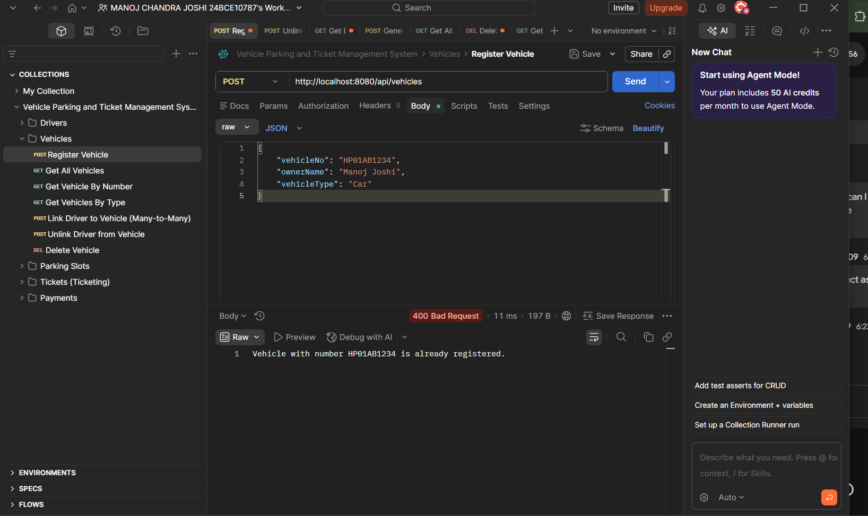
VECHILE SECTION ---REGISTERING VECHILE 400 BADREQUEST AS VECHILENO IS ALREADY REGISTERED
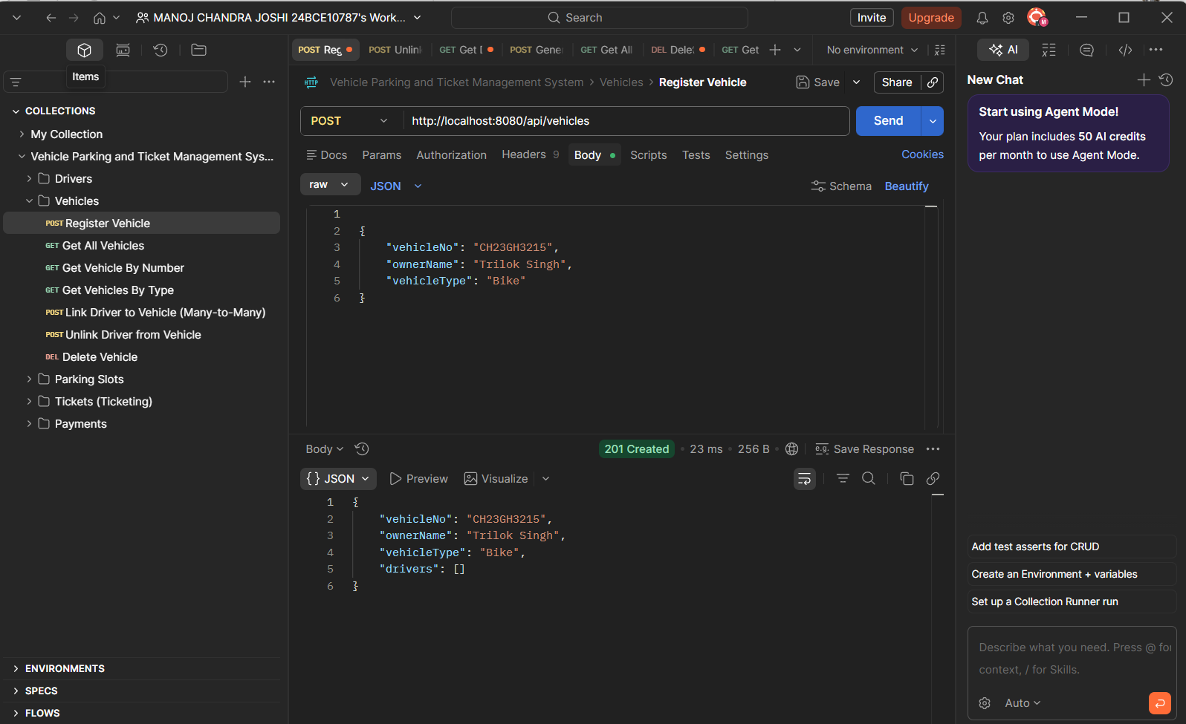
Register VehicleBIKE
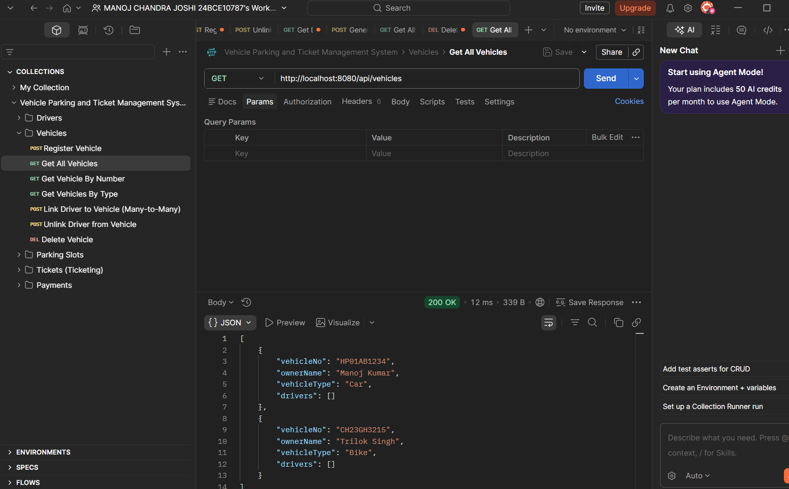
Get data of vehiclespost

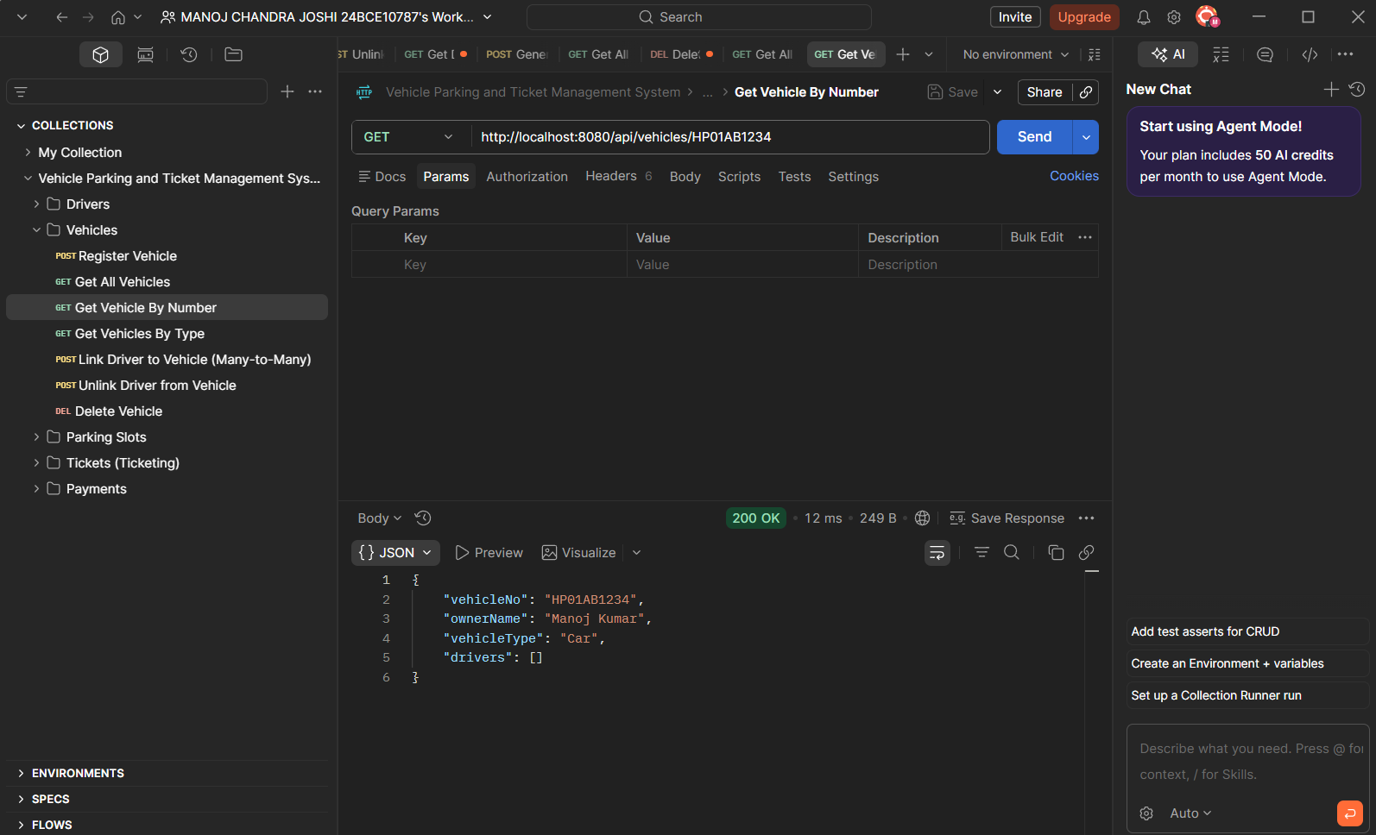
GET VEHICLE BY NUMBER
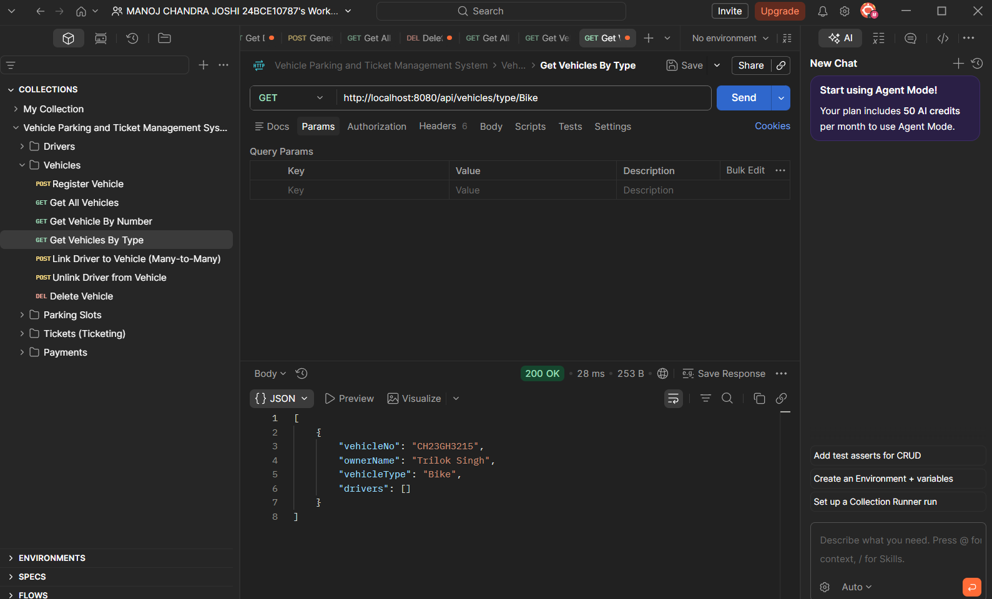
Get vehicle by TYPE

